**ST. XAVIER’S COLLEGE**

**(Affiliated to Tribhuvan University)**

Maitighar, Kathmandu



**Computer Assignment #7**

**Submitted by:**

Arun Sanjel  
013BSCCSIT010

**Submitted to:**

|  |  |
| --- | --- |
| **Er. Anil K. Sah**  Lecturer  St. Xavier’s College |  |

**Date of Submission: September 1, 2015**

**Source Code**

//---------------------------------------------------------------------------

#include <vcl\vcl.h>

#pragma hdrstop

#include <math.h>

#include "transformation.h"

//---------------------------------------------------------------------------

#pragma resource "*.dfm"

TForm1 *Form1;

//---------------------------------------------------------------------------

__fastcall TForm1::TForm1(TComponent* Owner)

: TForm(Owner)

{

}

//---------------------------------------------------------------------------

void __fastcall TForm1::butTransClick(TObject *Sender)

{

outPanel->Canvas->FillRect(ClientRect); // Clear Canvas

int i ,j,tx,ty,a,b;

int h,w;

h =inPanel->Height; //Gets Canvas Height

w= inPanel->Width; // Gets Canvas width

tx= StrToInt(inTx->Text); // Gets translation X coordinates

ty= StrToInt(inTy->Text); // Gets Translation Y coordinates

//Translation

for(i=0;i<=h;i++){

for(j=0;j<=w;j++){

a=i+tx;

b=j+ty;

outPanel->Canvas->Pixels[a][b] = inPanel->Canvas->Pixels[i][j];

}

}

}

//---------------------------------------------------------------------------

void __fastcall TForm1::inRotateClick(TObject *Sender)

{

outPanel->Canvas->FillRect(ClientRect); // Clear Canvas

int i,j;

int h,w;

h =inPanel->Height; // Gets Canvas Height

w= inPanel->Width; // Gets Canvas Width

float a,b;

float angle= StrToFloat(inRo->Text)*(3.1415/180);

for(i=0;i<=h;i++){

for(j=0;j<=w;j++){

// Rotation

a=(i*cos(angle)- j*sin(angle));

b=(j*cos(angle) + i*sin(angle));

outPanel->Canvas->Pixels[a][b] = inPanel->Canvas->Pixels[i][j];

}

}

}

//---------------------------------------------------------------------------

void __fastcall TForm1::butScaleClick(TObject *Sender)

{

float sx,sy,a,b;

int i,j;

outPanel->Canvas->FillRect(ClientRect); // Clear Canvas

sx = StrToFloat(inSx->Text);

sy = StrToFloat(inSy->Text);

int h,w;

h =inPanel->Height;

w= inPanel->Width;

for(i=0;i<=h;i++){

for(j=0;j<=w;j++){

//Scale

a=sx*i;

b=sy*j;

outPanel->Canvas->Pixels[a][b] = inPanel->Canvas->Pixels[i][j];

}

}

}

//---------------------------------------------------------------------------

**Output Screen**

1. **Input Screen**

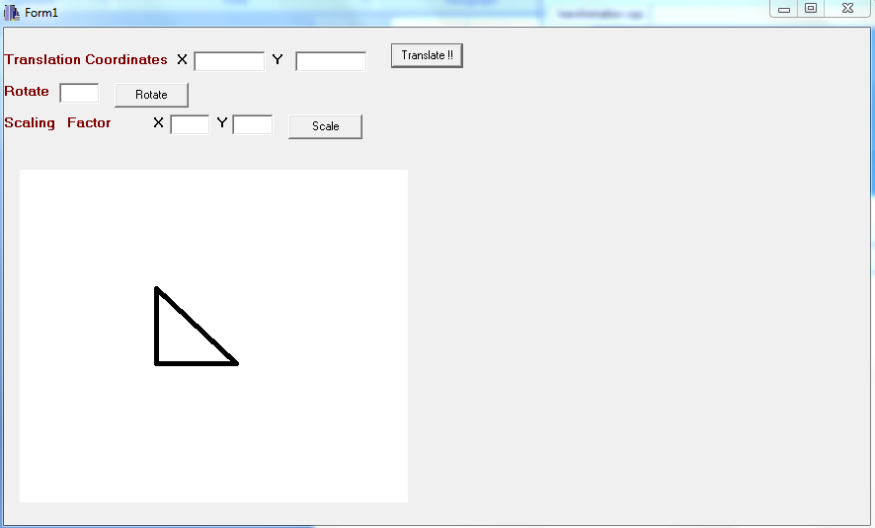

1. **Translation**

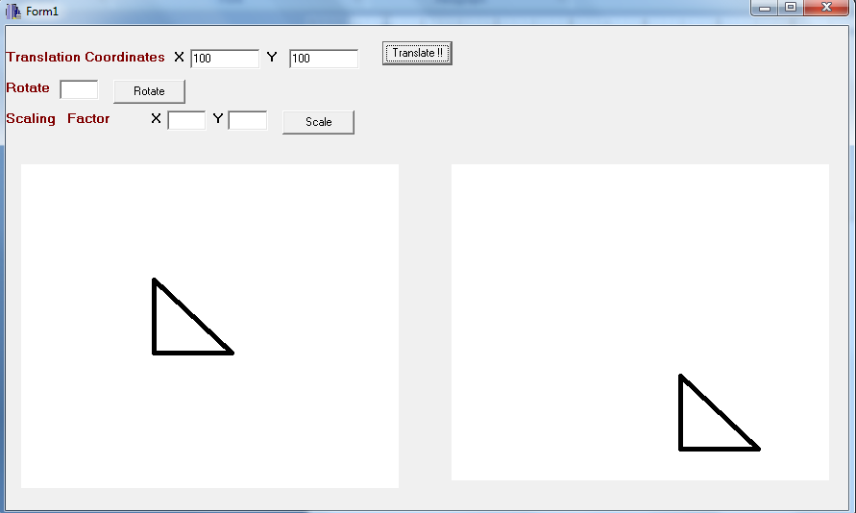

1. **Rotate**

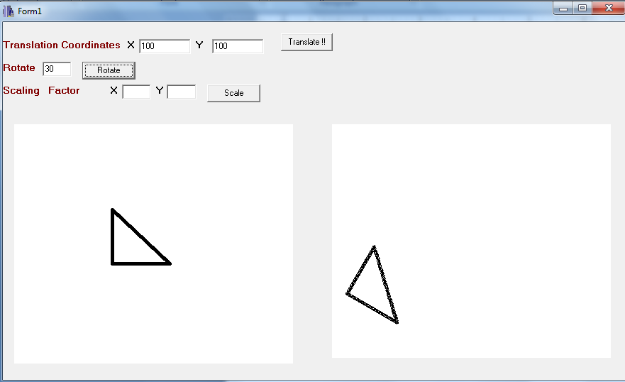

1. **Scale**

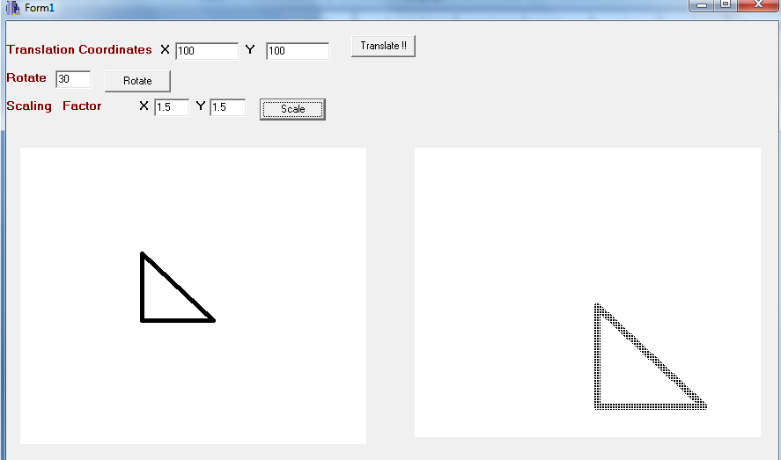

**Conclusion**

Hence, all transformation i.e. translation, rotation and scaling is done using C++ builder.